Version 1.0

Published February 2, 2022

Solution Architecture

Material Order Application

Prepared for: Sam Okasha, Nathan White, and Rob Toth

Prepared by: Lem Edillon and Richard McLeod on behalf of Convverge

**DRAFT DOCUMENT SUBJECT TO CHANGE DISCLAIMER**

This document is a work in progress and is subject to change without notice. In the event of discrepancy with prior versions, the information contained within this version of the document takes precedence.

**Table of Contents**

1. Introduction 1

2. Application Overview 1

2.1. Current State 1

2.2. Proposed Solution 2

3. Reporting Overview 6

4. Workflows Required 7

5. Effort Estimate 8

6. Outstanding Questions 9

7. Contacts and Notices 9

**Revision History**

|  |  |  |
| --- | --- | --- |
| Date | Person | Description of Change |
| January 25, 2022 | Lem Edillon | Version 1.0 – First working draft |
| February 2, 2022 | Lem Edillon | Version 1.1 – Submitted to Sanjel |

# Introduction

This document outlines the solution architecture and effort estimate for an application designed for ordering and transporting material and products that are to be used for oilfield cementing operations.

# Application Overview

## Current State

Sanjel currently uses email and Excel spreadsheets to manage the following high-level process:

1. A Bulk Plant Operator (BPO) requires product based on an operations forecast.
2. The BPO fills out a Material Requisition Form (Excel spreadsheet) to request a list of products. The BPO specifies a quantity of each product, when the product is required, and the product’s destination.
3. The Materials Requisition Form is emailed to the Supply Chain (SC) team.
4. The SC team determines where the product will be picked up from and where it will be delivered. Additionally, the SC team provides a purchase order (PO) number or internal transfer number (ITN) for each product instructing the BPO what number to receive against in the ERP system.
5. The SC team sends an email with delivery instructions to the Chem Van Driver who will transport the product. Alternatively, the product can be delivered directly to the destination by a third-party transport.
6. The SC team sends an email to the BPO that the product is loaded and when it is expected to arrive.
7. The driver delivers the product to the BPO and a Materials Transfer Sheet is completed indicating what products were delivered.
8. The process ends when the products are received and the BPO has received the products against the appropriate PO number in the ERP system. Whatever product was not received is ordered on the next Materials Requisition form.

Issues with current process:

* Revisions are made either by phone, text, or email to the order that are not always captured on the Materials Requisition Form.
* Volume of email traffic.
* Lack of visibility from all stakeholders of the process.
* Lack of analytics due to lack of data centralization.
* Potential for errors and miscommunication in the ordering process.

## Proposed Solution

Convverge proposes to build a solution using Microsoft Power Apps (Canvas App), Power Automate, Power BI and SQL Database. Security will be controlled using Azure Active Directory. The app will be designed for desktop or tablet. The driver/BPO view be optimized for mobile.

The Power App will be designed with three main components:

1. Material Acquisition
2. Shipments
3. Requisitions/Trips
4. Driver/BPO View

The process for ordering would be as follows:

* A BPO requires product based on operational forecast.
* The BPO logs into the Material Order App and navigates to Material Acquisition. Here the BPO can see all products that have been delivered, that are being shipped, and that are “Pending” or have yet to be transported.
* The BPO adds to Material Acquisition which products are required. When a new material is added and has the status of “Pending”, the SC team receives a notification that new material is required.
* The SC team logs into the app and navigates to Shipments. The SC team can see all completed and in progress shipments. The SC team creates a new shipment by clicking “Create New Shipment” in the upper right corner of the screen.
* This will take the BPO to the Requisitions/Trips screen. Here the SC team can build a shipment based on the pending materials in the Material Acquisition screen.
* When the SC Team has completed the requisition, “Dispatch” is selected. This changes the status of the products added from the order list from “Pending” to “Ordered”. A notification is sent to both the BPO and the Chem Van Driver that a requisition has been completed.
* The Chem Van Driver navigates to the Driver/BPO View of the requisition. The driver picks up the products at the designated locations and delivers the products to the bulk plant. The driver completes a checklist of products received in the Driver/BPO View of the application.
* The BPO navigates to the Driver/BPO View in the app and records that the volume of products actually received versus ordered. This changes the status of the product to “Delivered”. The BPO has the PO number that was recorded by the SC Team in the app to receive against. When the materials have been received, and auto generated Materials Transfer Sheet is emailed to the BPO, SC Team, and Driver.

### Material Acquisition

Material Acquisition is where the BPO can review all received products, products being delivered, and build future product requests. The left column “Matieral” will list all of Sanjel’s products available for order and delivery. The user will have the ability to filter by District so that only the products applicable to the user’s bulk plant are shown.

Additionally, the user can filter between the different statuses of each product to show only orders that are pending, ordered, delivered, etc. Note that screen can be viewed by all districts and the entire SC team. This provides everyone involved the process with the ability to see what’s being ordered, what is in progress, and what is outstanding.

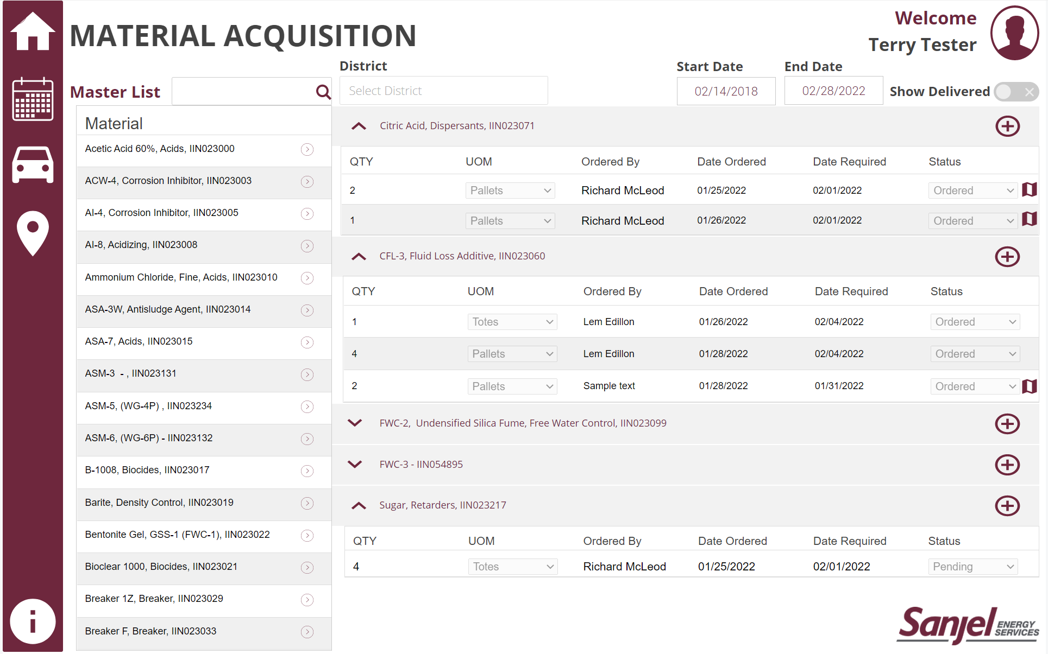

### Shipments

The Shipments screen is used to view all completed, in progress, and pending requisitions/shipments. The left side of the screen is a calendar view of current and upcoming shipments. The right side of the screen summarizes all the requisitions/shipments in a card-type format with some high-level details. Clicking on the requisition cards will take you to the specific requisition screen. The upper right corner is where the SC team would create a new shipment.

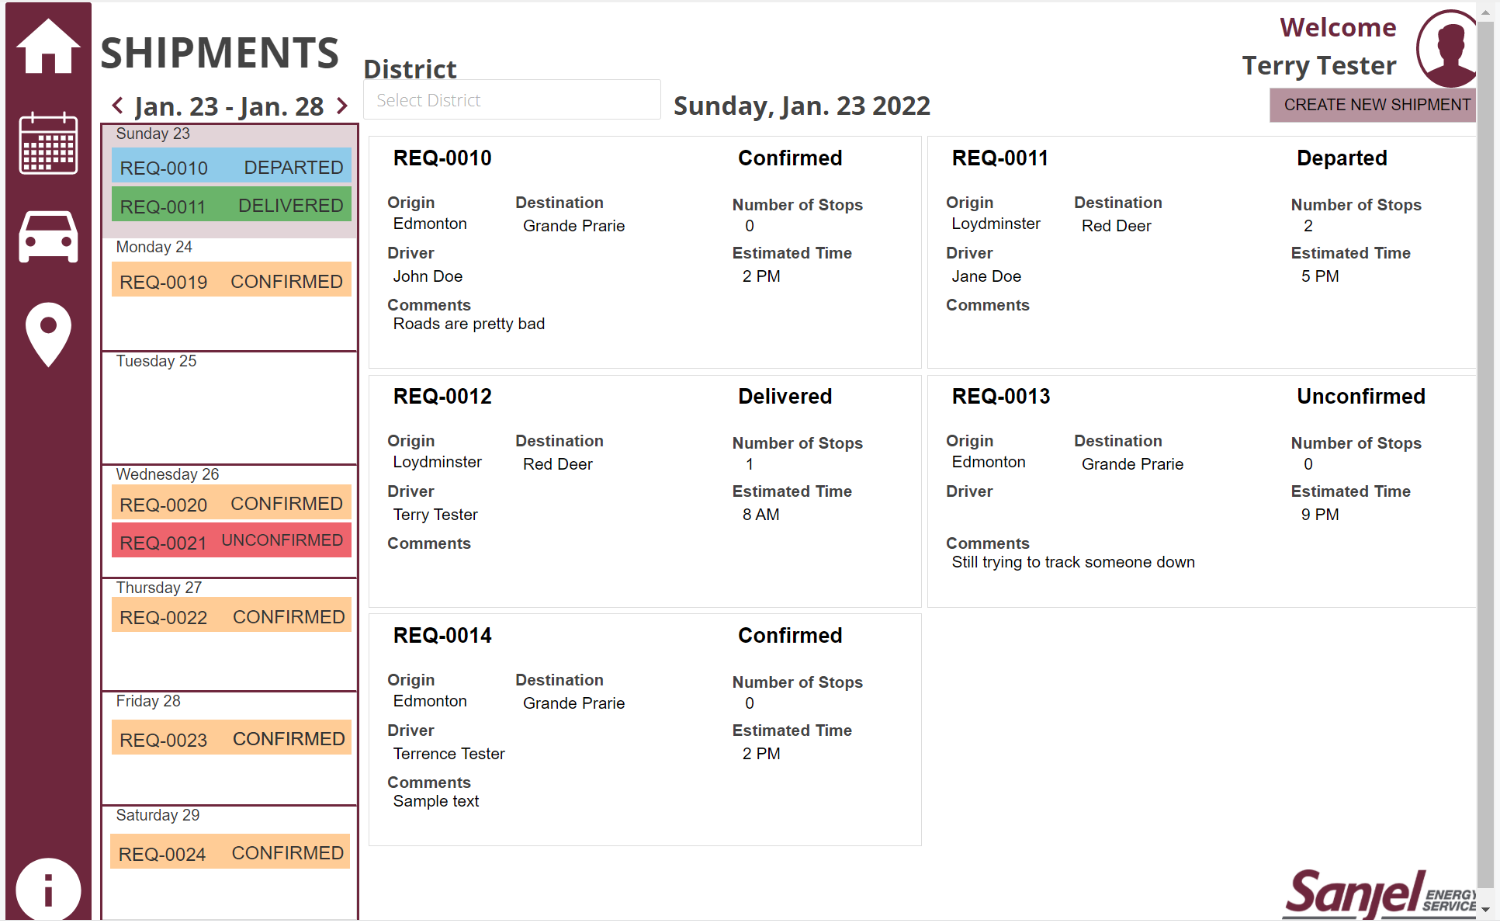

### Requisitions/Trips

The Requisitions/Trips screen is where a shipment of materials is created based on the products specified on the Materials Acquisition List. The SC team can create a new shipment that will have a unique requisition number. The SC team can add products to the requisition until a shipment is full (approximately 20 pallets for a Sanjel Chem Van). The SC team can specify where the product will be picked up, its destination, the date required, what kind of trucking service will be used, and what PO or ITN number corresponds to each product. Comments can be added on a per product basis.

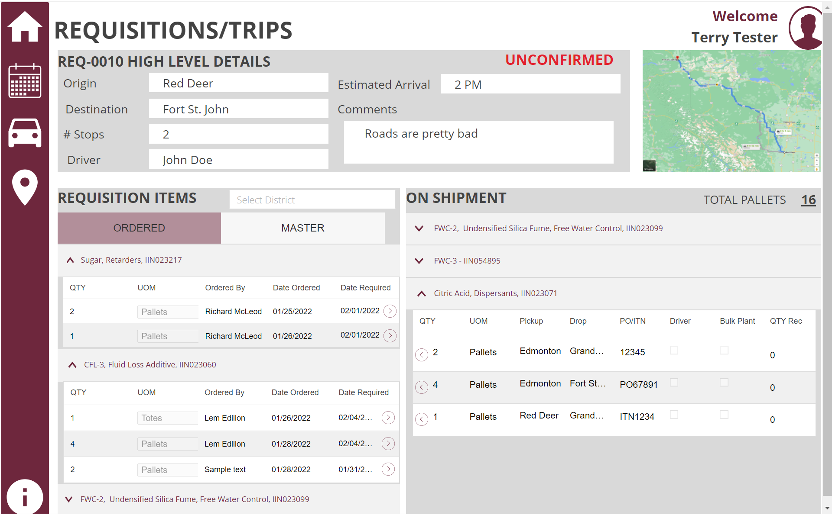

Once a requisition has been built, the SC team can click “Dispatch”. At that point, a notification is sent to the Sanjel Chem Driver and the associated products on the order list have a status changed from “Pending” to “Ordered”. At this point, the requisition can no longer be revised unless unlocked by the SC team.

The BPO can also specify in the “On Shipment” screen how many pallets of any specific material actually arrived at the bulk plant versus what was ordered. If the material was partially delivered, the quantity of undelivered material will appear back on the Material Acquisition screen.

### Driver/Bulk Plant Operator View

The Sanjel Chem Van Driver and BPO have access to the requisition/trip through the app. When the driver picks up the product, the driver can fill in a checkbox indicating that the material has been picked up as per the example below. The trip is also organized by stops and includes a map view for journey management.

# Reporting Overview

The reporting platform for the solution will be Power BI, which includes both an analytics dataset and reports. The following details were identified as part of the initial discovery session and can be adjusted or expanded as required.

Identified Information and Measures:

* Time from BPO order request to delivery per product, per district.
* Time from creation of requisition to delivery per product, per district.
* Count of trips (shipments), per month, quarter, etc.
* Trips by driver, per month, quarter, etc.
* Quantity of product shipped, per month, quarter, per district, or total.

Viewing Permissions:

* Managers can view all checklists, with the ability to filter to employees in their district.
* Row Level Security (RLS) will integrate with Active Directory to ensure that Mentors and Employees see only checklists attached to them.

# Workflows Required

* BPO from a specific district adds over 20 pallets of product.
  + To: SC team
  + From: BPO
  + Content: A notification to create a new requisition.
* BPO can manually trigger a request for a requisition/shipment
  + To: SC team
  + From: BPO
  + Content: A notification to create a new requisition.
* New requisition completed.
  + To: BPO, Chem Van Driver
  + From: SC team
  + Content: Notification that product must be picked up and delivered by a specific date.
* Product picked up
  + To: BPO, SC team
  + From: Driver
  + Content: Notification that product was picked up by the driver.
* Product delivered
  + From: BPO
  + To: Driver, SC team
  + Content: Notification that product was delivered.
* New product added to Material Order App
  + From: SC team
  + To: BPOs, Drivers
  + Content: Notification of new product available for pickup and delivery.

# Effort Estimate

|  |  |  |
| --- | --- | --- |
|  |  |  |
|  | **Power Apps, Power Automate, Power BI and SQL Database** | |
| **Deliverable** | **Est. effort (hrs)** | **Est. price ($)** |
|  |  |  |
| *Business Requirements* |  |  |
| *Confirm Phase 1 Requirements | 10 | 1,500.00 |
|  |  |  |
| *Development* |  |  |
| Implement database architecture | 10 | 1,500.00 |
| Application Design | 20 | 3,000.00 |
| Application Development | 32 | 4,800.00 |
| Notification Workflows | 8 | 1,200.00 |
| Approval Workflows | 5 | 750.00 |
| Security Roles and Set Up | 5 | 750.00 |
| Data Model & Measures (Power BI) | 7 | 1,050.00 |
| Report Development | 26 | 3,900.00 |
|  |  |  |
| *Delivery* |  |  |
| Project Management and Team Coordination (~17% of project cost) | 19 | 2,880.00 |
| QA and UAT (~8% of project cost) | 13 | 1,920.00 |
| **Total** | **155** | **$23,250.00** |

*\*Effort has been completed to this point*

# Outstanding Questions

|  |  |
| --- | --- |
| **ID** | **Question** |
| 1 |  |

# Contacts and Notices

Please do not hesitate to contact us with any questions or concerns you may have. We are always here to help.

Sincerely,

**Lem Edillon**

leme@convverge.com

403-988-5677